# ***Document Titled: “Day 3 API Integration And Data Migration”***

What to Submit:

o A report documenting:

♣ API integration process.

♣ Adjustments made to schemas.

♣ Migration steps and tools used.

Screenshots of:

♣ API calls

♣ Data successfully displayed in the frontend.

♣ Populated Sanity CMS fields.

o Code snippets for API integration and migration scripts.

Day 3 - API Integration and Data Migration:

OBJECTIVE:

The focus for Day 3 is integrating APIs and migrating data into Sanity CMS to build a functional marketplace backend. I learn how to utilize APIs for reference, migrate data into Sanity CMS. This approach replicates real-world practices and prepares to handle diverse client requirements, including integrating headless APIs or migrating existing data from popular eCommerce platform.

**VALIDATION AND ADJUST *PRODUCT DATA SCHEMA:***

The Schema in sanity CMS needs to align with the API structure to ensure seamless data migration. Key fields to validate include:

***PRODUCT SCHEMA:***

Name {string}: Product Name

Price{number}: Product Price

Discount{number}: Discount Percentage

Description{string}: Description

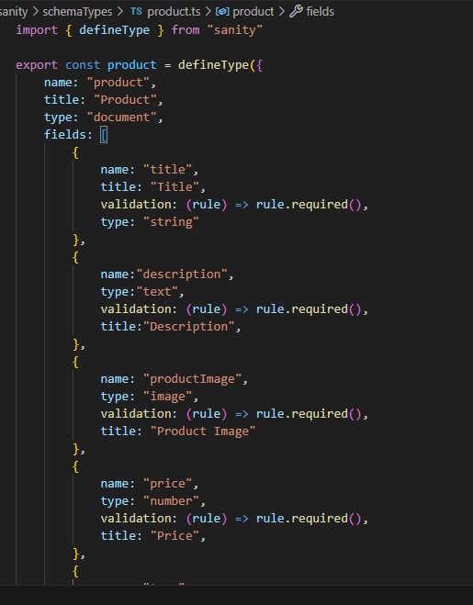

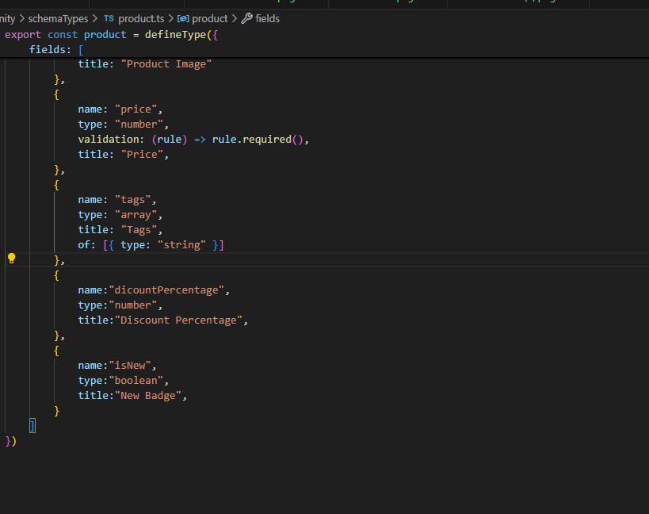

**DATA MIGRATION:** 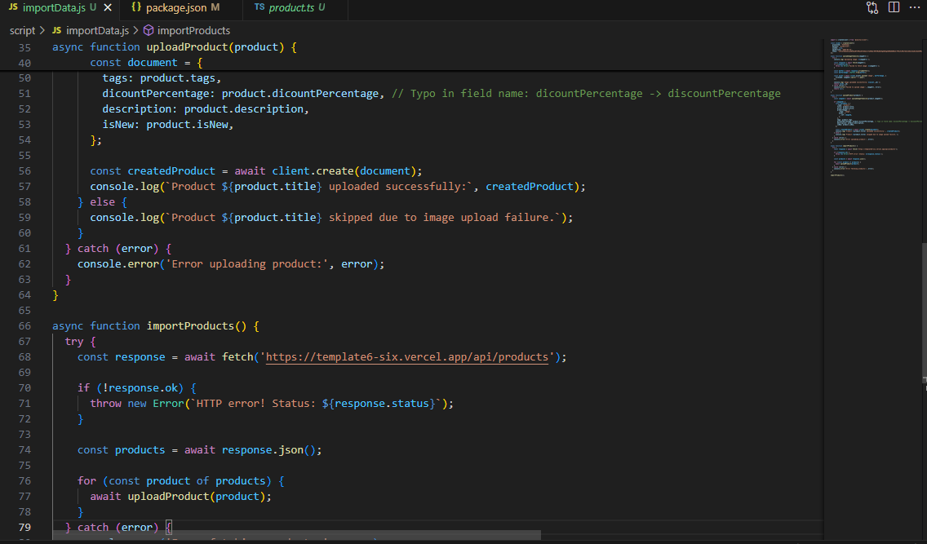

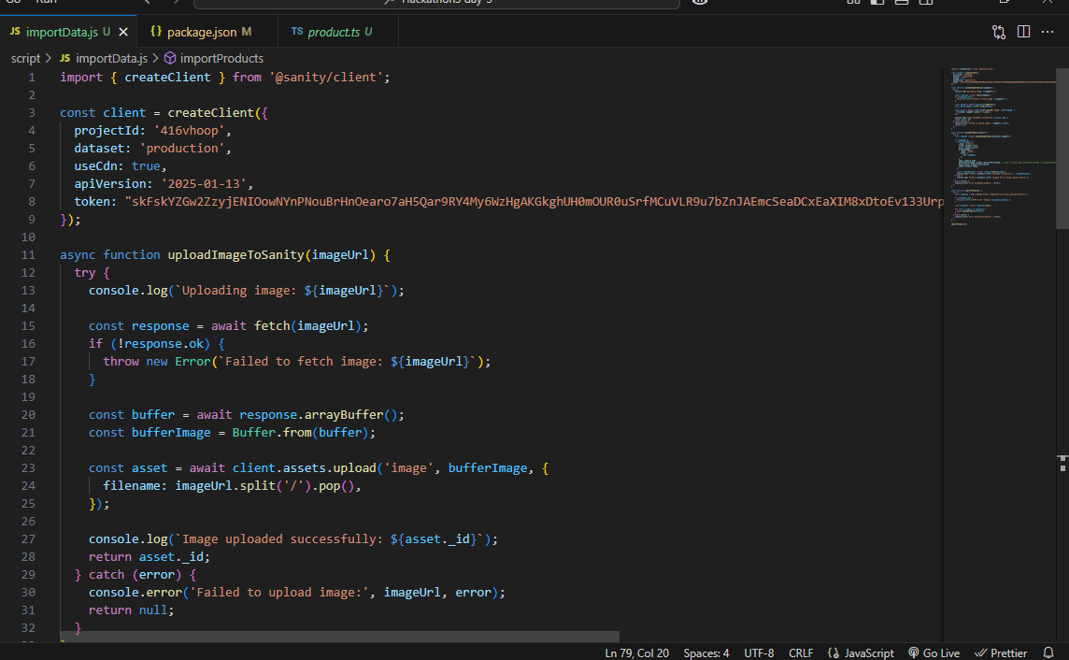

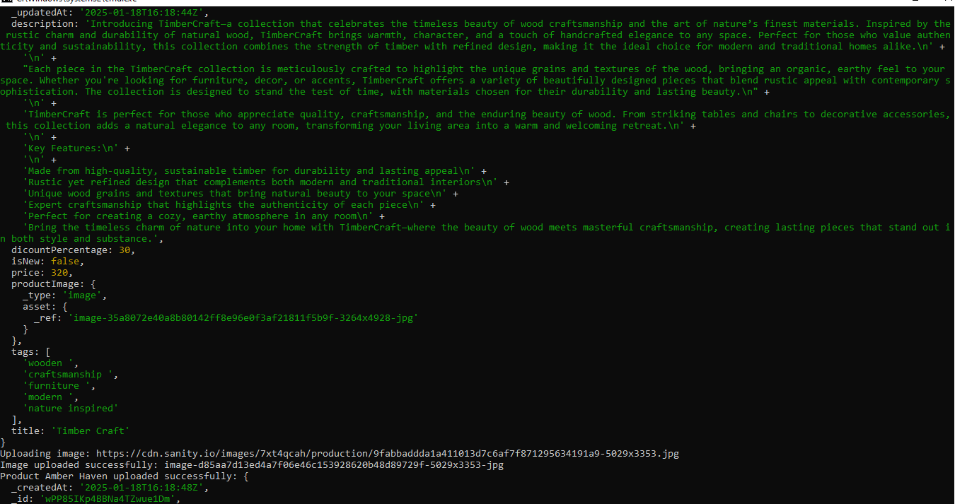**Package.json** :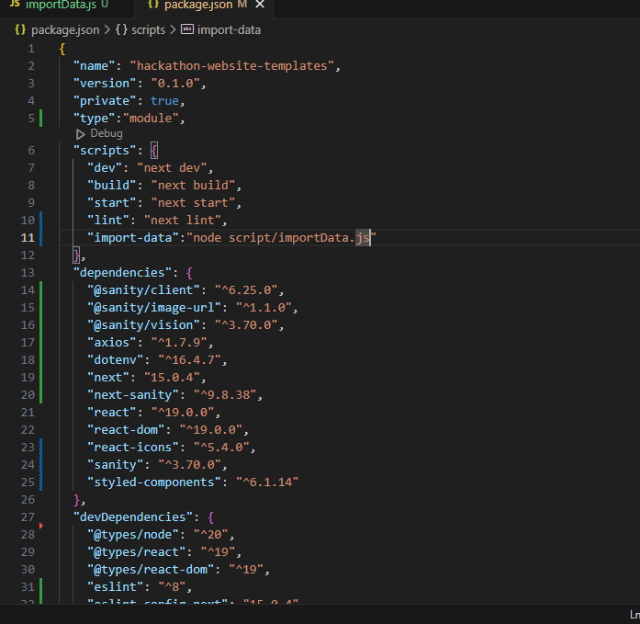

**FLOW CHART AND API INTERATION:**

[API / External Data flow]

|

[Fetch Data]

[Transform Data for sanity CMS]

|

[Import Data into Sanity]

|

[Next js Frontend]

|

[Display Data Dynamically]

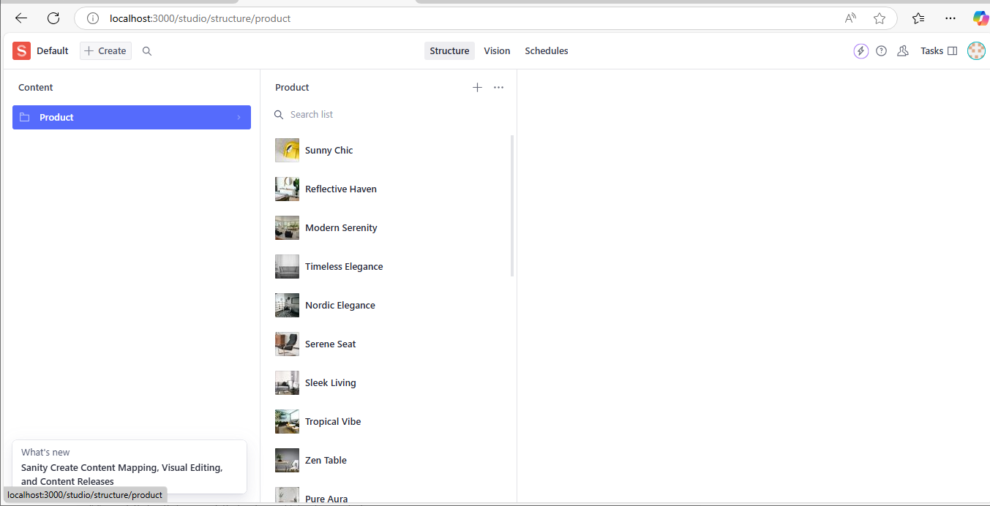

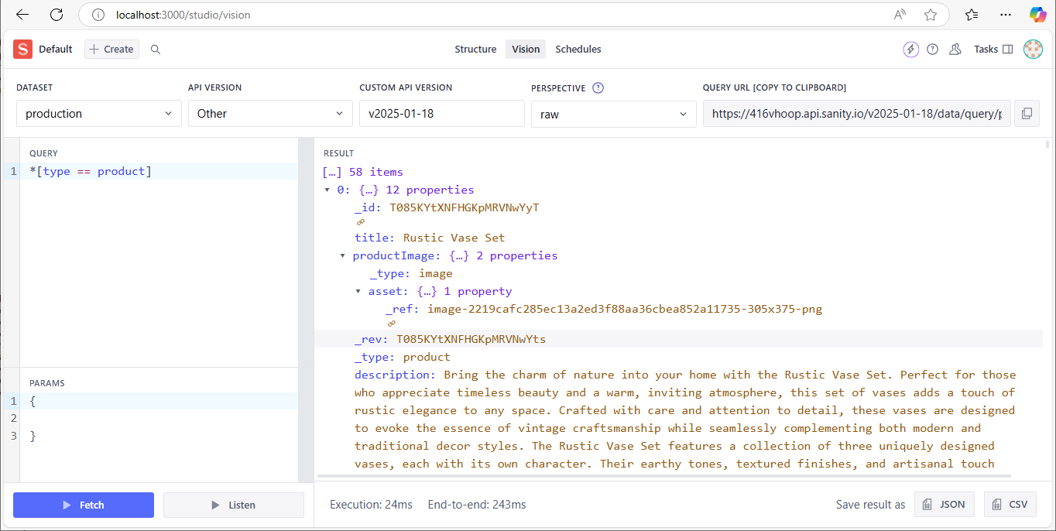

**Name:SAJAL IRSHAD**

**ROLL NO: 00475635**

**\*-------------\***